**Guided Capstone Project Report**

The Big Mountain (BM) ski resort offers a lot in terms of facilities compared with other resorts in the state of Montana and in the rest of the country. After initially analyzing the data that was available and preprocessing to make it the most applicable for our business interests, modeling was applied to be able to predict the best pricing for the resort based on market value and comparable features. Initially the data for the single resort was extracted and the Random Forest model was applied to the initial data without the Big Mountain resort data. This was done because we are using the pricing at other resorts as a basis for our justification for price increase and we do not want for the current price of BM to bias that. It found that the mean absolute error is $10.39 and the standard deviation was $1.47. When the model was applied to the BM data, it found that the modeled price is $95.87, which is promising even with the $10.39 mean absolute error. This is a good justification for increasing the price for the resort but further analysis was done to visualize the basis for this.

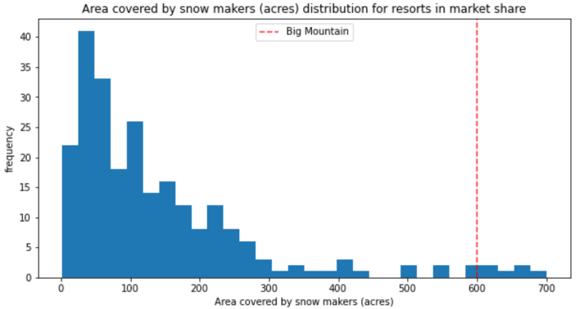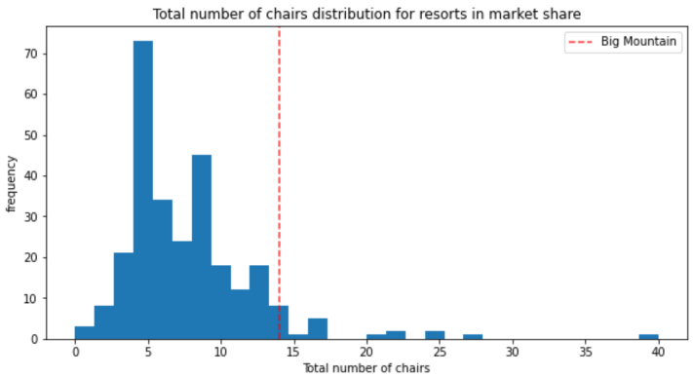The Big Mountain Resort in market context shows that the most important features for BM is are vertical drop, snow making area, total chair lifts, fast quads, runs, longest run length in miles, trams, and skiable terrain area. I visualized the position of the Big Mountain resort compared to other resorts to see how comparable it is and to see how it can be used as a basis for the price. First, I compared the current price with other resorts around the nation and then just in Montana to see the current place in the market value. Some of the features where BM ranks higher among other resorts are snow making area, number of chairs, runs and fast quads, and skiable terrain, which can be seen in the following charts.

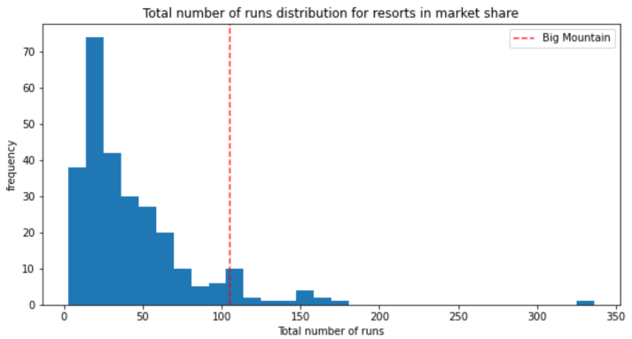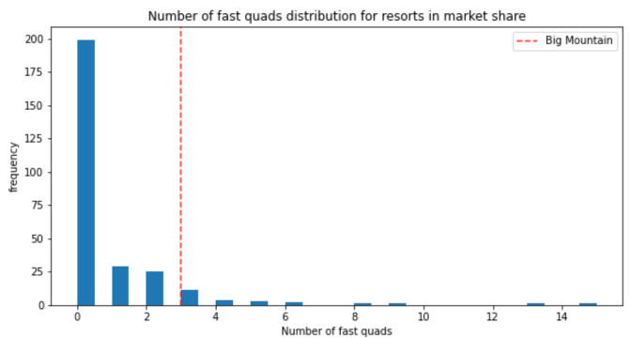

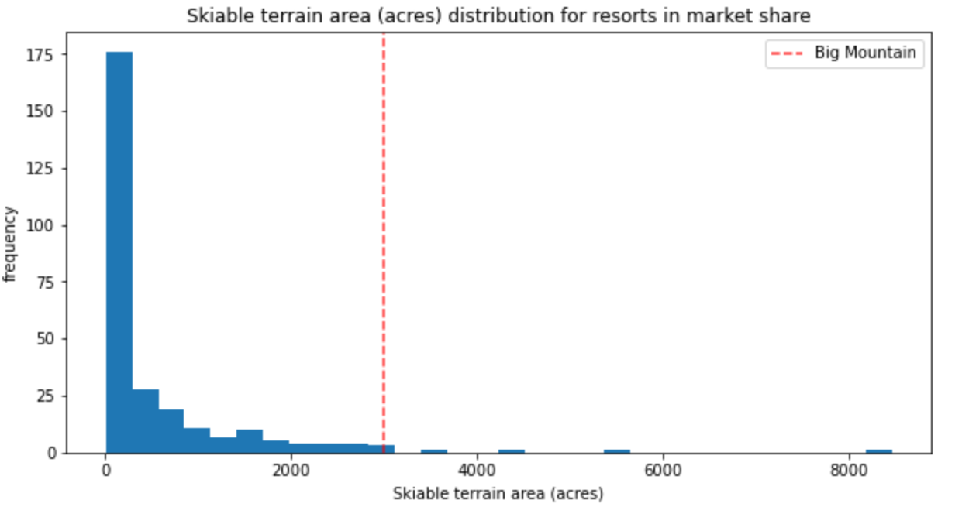

After the modeling is applied and 4 scenarios are posed, my recommendations are that Scenario 2 and 3 are considered because they are the ones that increase the revenue and the support for ticket increase the most. Scenario 1 involves reducing the number of runs available at the resort, which ultimately would cause the ticket price to have to decrease as well as the revenue as the amount of closed runs increases, seen in the graphs below. This is not the goal for the business executives however.

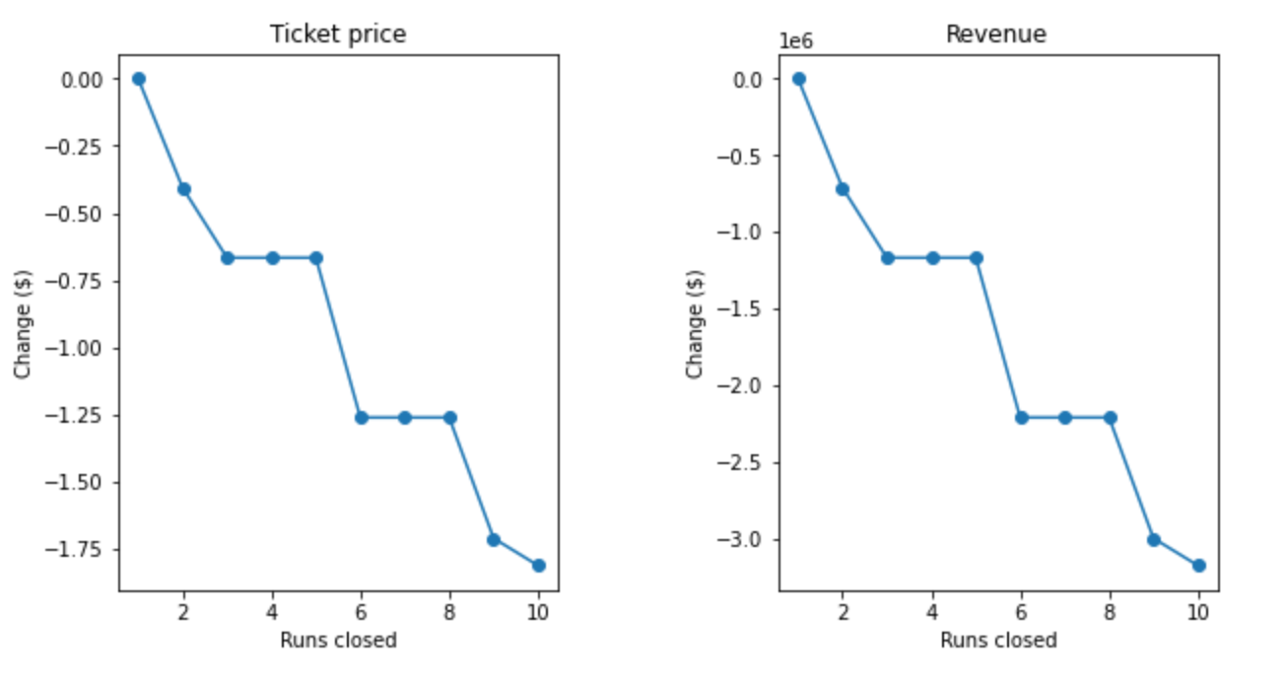

Both scenarios 2 and 3 are similar in that they add a run, increase the vertical drop and add a chair lift, which accounts for the one that has recently been added, but the 3rd scenario also includes adding to the snow making area. This only changes the results slightly, making both scenarios viable and giving options to the business executives to decide which best fits their business needs. Both options support a ticket increase and therefore an increase in revenue.

The final scenario increases the length of the longest run by 0.2 miles which the model ultimately shows that it would make no change in the support for the ticket price increase because the length of the longest run is very low on the list of features that affect the price.